Git-HOL -1

STEP 1 & 2:

Configuration of Git is done.

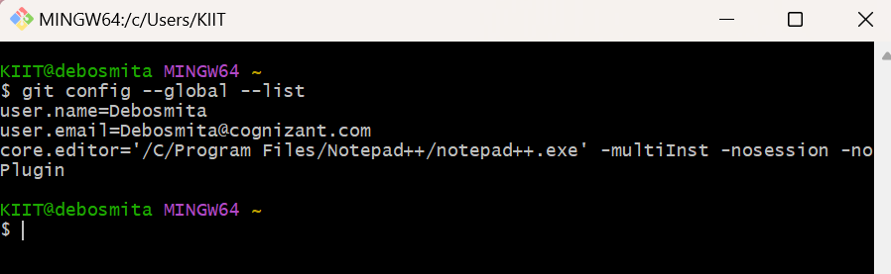

Integration of notepad++.exe is done, which is the default editor.

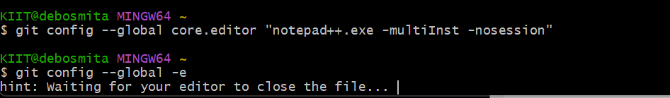

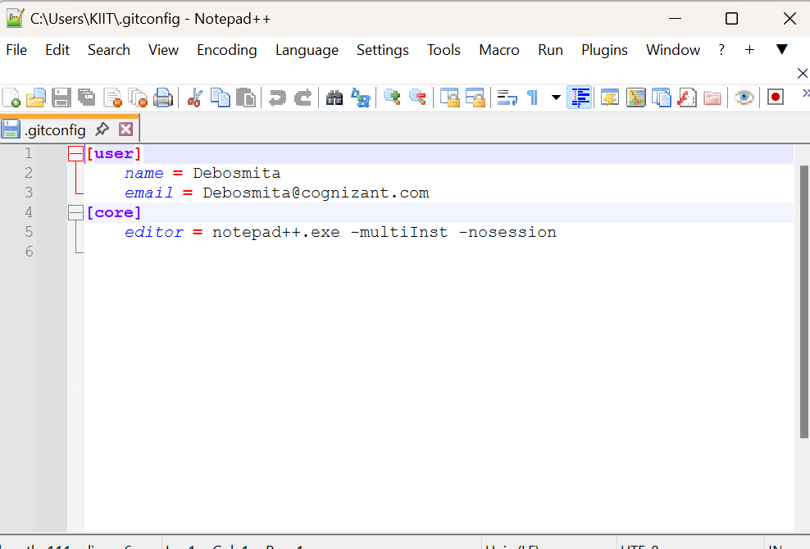

STEP 3:

A new project “GitDemo” is created nd initiated using the commands below in Gitbash.

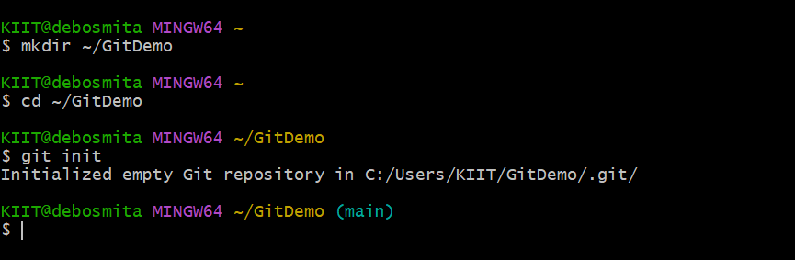

The command below displays all the hidden files in the Git working directory.

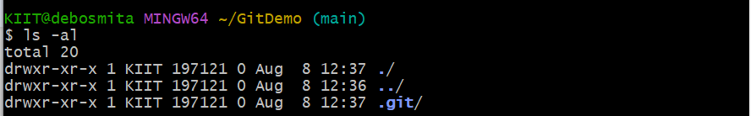

A new file “welcome.txt” is created and some content is added to it.

Then it verifies if the file is created.

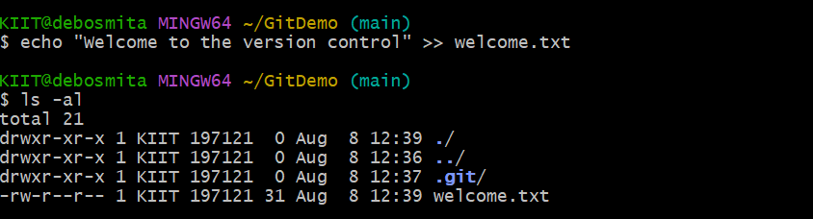

This command below is used to verify content inside the file.



The status is checked and now the file is available in the Git working directory.

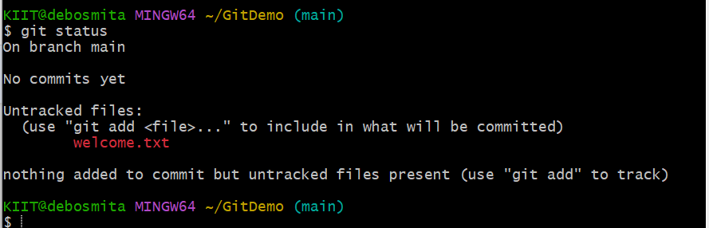

The command below will track the file using Git repository.

If multiline comments need to be added, we can open the notepad++ editor.

“$ git commit” will open the Notepad++ editor.

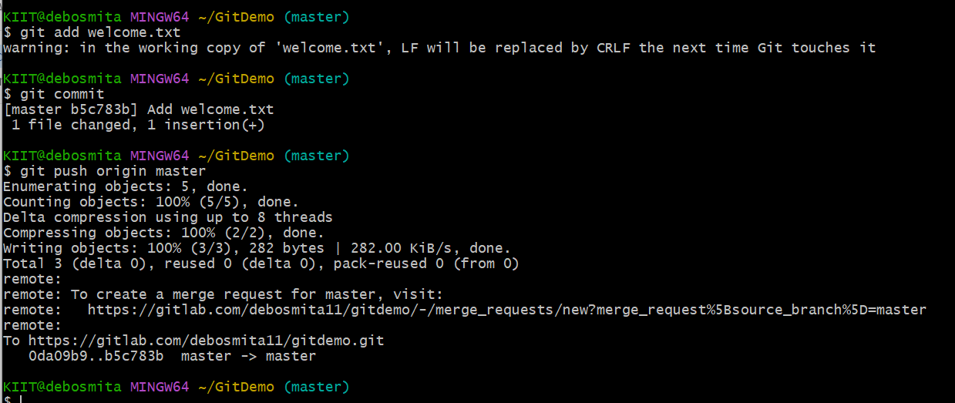

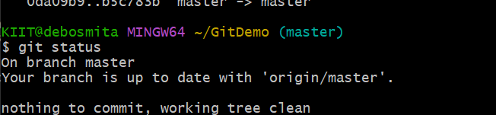

Finally the GitLab is setup and a new project is created with the name “GitDemo”.In the master branch, the latest commit is **“Add welcome.txt”**. That means your welcome.txt file is in GitLab, and your commit has been successfully pushed.

